Quick Reference Guide for Whole Blood Administration
** The administration of blood products is restricted to Paramedics individually and specifically trained and authorized to perform this procedure by the Operational Medical Director. **

Potential Indications:
- Hemodynamically unstable trauma patient (signs/symptoms consistent with hemorrhagic shock)
- Hemodynamically unstable medical patient (signs/symptoms consistent with hemorrhagic shock)
- Multiple patient incident with demonstrated/anticipated need for on scene blood products
Procedure Considerations:
- Early recognition of need by an experienced provider on scene is paramount for early activation and timely arrival of the EMS Supervisor.
- Conventional fluid therapy should be initiated via a 20-gauge catheter or greater in adults and an age-appropriate catheter in pediatrics, per protocol.
- Two (2) ALS providers must check and verify the blood type and expiration date
- Medications shall not be administered through the same line with blood products due to the potential for incompatibility.
- Do not delay the transport of a patient to definitive care.
Questions to ask yourself:
- Will the patient benefit from early blood administration?
- Do I have an appropriate size catheter or IO in place?
- Have I obtained a full set of vitals, including temperature?
Equipment will be utilized:
- QinFlow Warrior fluid warming device
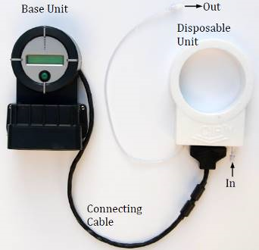
- Y-Type Blood administration drop set
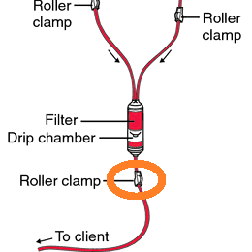

- Whole Blood
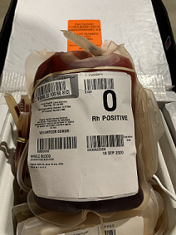
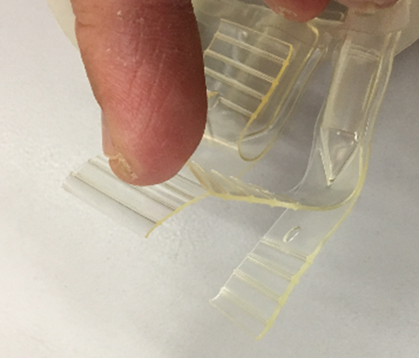
(Close up of the Y-port used to spike the bag)

Pediatric Considerations:
- Pediatric dosing is 10 – 20 ml/kg to start, titrated to effect
- If administering products to a smaller pediatric patient, utilize a syringe for controlled and accurate dosing

