Loudoun County Combined Fire and Rescue System
Procedures Manual
Blood Administration
** The administration of blood products is restricted to Paramedics individually and specifically trained and authorized to perform this procedure by the Operational Medical Director. **

Background:
The administration of blood products in the field likely increases the survivability in both trauma and medical patients who are experiencing massive hemorrhaging. Recent studies have shown that whole blood is the preferred choice for fluid resuscitation in these patients. Forward deployed whole blood for EMS use has the advantage of bringing this life-saving capability directly to the patient. The Field-Available Coordinated Transfusion Response (FACT*R) program remains an option to make additional blood products available on demand in select trauma scenarios, including multiple patient scenarios or prolonged entrapments. FACT*R creates a virtual supply which can be requested by EMS, packaged and brought from the hospital blood bank to the incident scene.

Potential Indications:
1. Hemodynamically unstable trauma patient (signs/symptoms consistent with hemorrhagic shock).*
2. Hemodynamically unstable medical patient (signs/symptoms consistent with hemorrhagic shock)
a) Suspected GI bleed, ruptured abdominal aortic aneurysm, severe OB/Gyn hemorrhage.
3. Multiple patient incident with demonstrated/anticipated need for on scene blood products.

*An isolated head injury is not an indication for blood products. Potential candidates should have injuries that resulted in major blood loss and which are felt to be potentially survivable (some degree of consciousness witnessed by trained first responders).

Procedure Considerations:
- Baseline vital signs will be obtained prior to administration of blood or blood products and monitored every 5 minutes throughout procedure.
- Conventional fluid therapy should be initiated via a 20-gauge catheter or greater in adults and an age-appropriate catheter in pediatrics per protocol.
- Early recognition of need by an experienced provider on scene is paramount for early activation and timely arrival of the EMS Supervisor.
- Generally it will take 20 minutes or longer from the time of request for FACT*R blood products to arrive on scene (depending on distance from supplying hospital).
- FACT*R program Blood products for field deployment are maintained at Inova Loudoun Hospital and Inova Fairfax Hospital.
- Activation of the FACT*R process is initiated by the Attendant in Charge (AIC) in cooperation with the Incident Commander (IC) through a direct phone call with the OMD via ECC phone patch.
- FACT*R blood products will be available at the respective facility within 15 minutes of the request.
- Chain of custody for all blood products is required.
- The EMS Supervisors will carry Low Titer Type O Rh Positive whole blood.
- Two (2) ALS providers must check and verify the blood type, and expiration date.
- The following will be included when FACT*R blood products are requested (depending on product availability):
  - 2 to 4 units of Low Titer O positive Whole Blood
OR
  - Component therapy, up to:
    - 5 units of packed red blood cells (PRBC’s)
    - 5 units of liquid plasma
1 unit of platelets
- Blood Administration will prompt automatic review by the OMD for Quality
Assurance, Quality Improvement, and medical necessity of procedure.

Warnings:
- Potential benefits of transfusion should outweigh risks.
- Transfusion of blood products is generally considered safe but involves some chance of complications including:
  - Transfusion reaction
  - Transmission of infectious disease
- Do not delay transport of patient to definitive care. If the patient is extricated and ready for transport, do not wait on scene for blood to arrive.
- Medications shall not be administered through the same line with blood products due to the potential for incompatibility.
- If the temperature dot indicator on the blood products has changed to red, the products shall not be used.
- Platelets are stored at controlled room temperature and shall be administered directly to the patient and not flowed through the fluid warmer.

Performance Indicators:
- Proper communication chain and seamless administration.
- Proper documentation and chain of custody of the blood.
- Improvement and/or stabilization in the patient’s vitals and condition.

Blood Administration
- AIC will identify the potential need for blood products
  - Are they hemodynamically unstable from blood loss?
  - Will they benefit from early blood administration?
- AIC will request an EMS Supervisor to the scene for the potential need for blood products. The EMS Supervisor will make contact with the Medical Director for authorization.
- Obtain Proper Authorization
  - Contact the Medical Director through ECC phone patch (MD 600 or designee).
  - Advise OMD of the situation (including gender and approximate age < or >50 as appropriate) and findings which support need for blood products.
  - Request will be approved or denied. If approved, the EMS Supervisor will work with on scene providers to administer the whole blood carried on their unit. In situations where FACT*R blood products are requested, the OMD or designee will notify appropriate hospital to prepare the blood products.
      - Inova Loudoun 703-858-6095
      - Inova Fairfax 703-776-3401
- When FACT*R blood products are approved, arrangements will be made through the IC for approved courier to pick up the blood products.
  - A separate incident will be created in CAD.
  - Loudoun ECC Dispatch algorithm will dispatch closest appropriate unit to pick up blood and supplies at designated emergency dept., and bring to scene.
- Establish 2 large bore IV’s when practical and age appropriate. IOs are an option for blood but infusion rates are slower. Administer IV fluid as necessary to maintain perfusion while waiting for blood products to arrive. If fluid warmer is available on scene, use it to administer warm IV fluids. Instructions on warmer setup begin at step #19.
- Prior to administration of products, obtain a full set of appropriate vitals to include patient temperature, when practical.
- Obtain informed consent for blood transfusion if patient is capable of giving consent (or someone legally authorized to consent for the patient is present to give consent in a reasonable time under the circumstances). If unable to get informed consent with emergent need for blood, blood may be given under the concept of implied consent.
***Note: While the information and pictures below depict saline being administered first and always connected to the administration tubing, this is not a requirement. If blood products are immediately available they may be given without delay. You may also utilize the additional Y-port to prepare your next product while the current product is flowing. Absolutely only one side of the Y-port shall be flowing at a time.
- In preparation of receiving blood products, utilize open Y-type blood tubing, close both upper roller clamps, and spike a 1L bag of normal saline. | 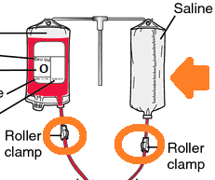
- Open the upper roller clip attached to the saline bag and prime the tubing. Once the tubing is primed close the lower roller clamp. | 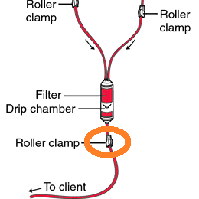
- Begin infusing IV fluids through this set-up in conjunction with a fluid warming device.
- Preserve the blood products upon their arrival and be sure to keep the container shut unless removing units. In regards to the FACT*R component package, this is especially important for the box of platelets which should be opened last after all other products administered.
- The FACT*R component blood products will arrive in two identical shaped boxes as pictured below. One will be marked “blood products” and the other “platelets”.

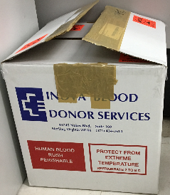
- PRBC’s |  | 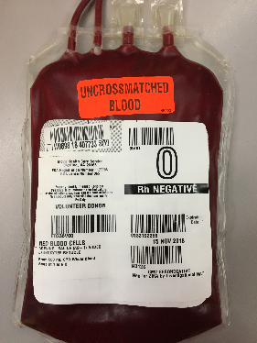
- Liquid plasma |  | 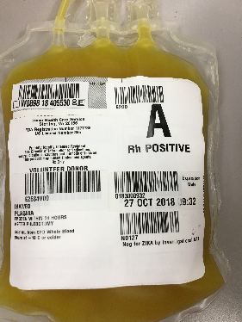
- Platelets |  | 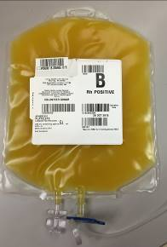
- Note: Plasma and platelets look very similar in appearance; however, they will be packaged in different boxes and the bag of platelets is larger in size than the plasma. Pictured below.
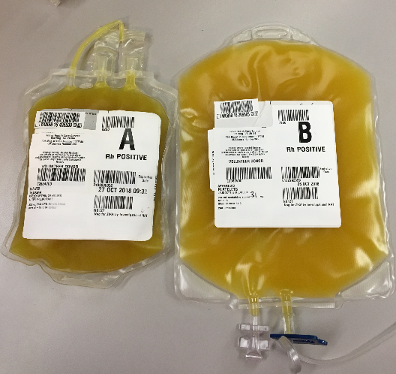
- Blood product labeling:

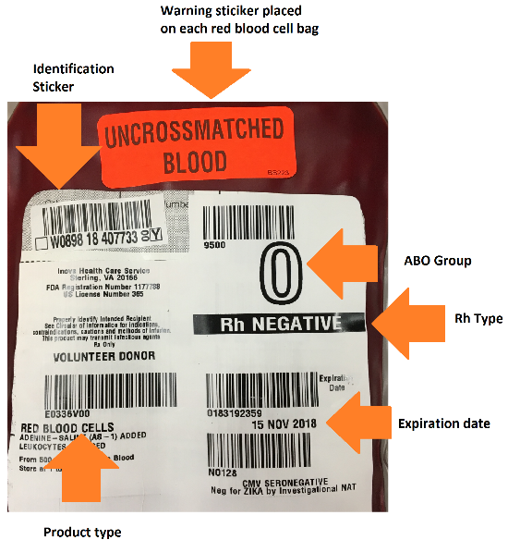

- The QinFlow Warrior devices are carried by the EMS Supervisor, but will also arrive in a StatPack when FACT*R blood is requested. Its contents are pictured below:
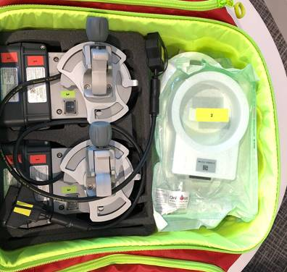

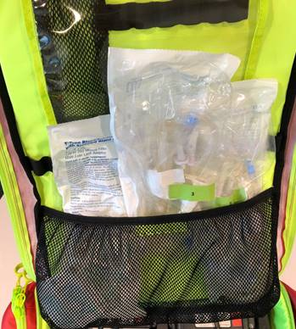

- Remove the QinFlow Warrior base unit with battery from the StatPak.
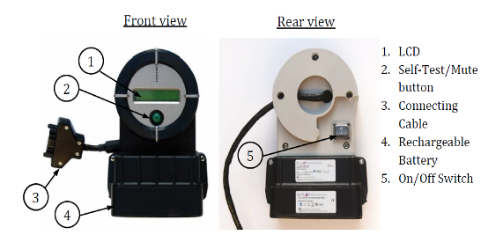
- Remove the disposable unit and open its sterile packaging. | 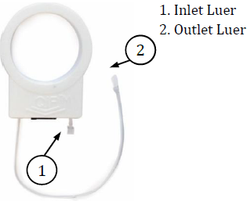
- Connect the disposable unit to the base unit. | 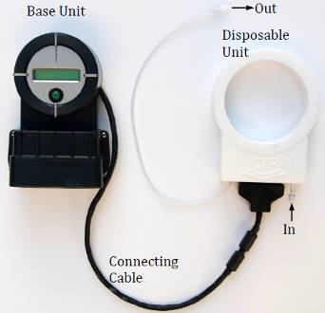
- Close off the lower roller clamp of the tubing. Disconnect the IV tubing from the patient and connect the tubing to the inlet luer of the Disposable Unit. Ensure patient’s IV is not back-flowing when temporarily disconnected.
- Open the lower roller clamp and start flowing saline through the Disposable Unit. Once the tubing is completely primed/flushed with saline, activate the Warrior device by turning on its power switch located on the back of the unit. The LCD displays the “Initializing…” message and will you will hear a steady beep for a few seconds. |  | 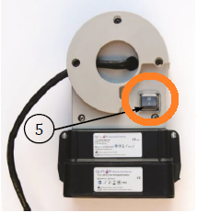
- The system will reach its set-point temperature in a few seconds. The LCD displays: Heating Tout: outflow temp (inflow temp).
- Connect the outlet luer directly to the patient’s IV/IO catheter or extension set and begin flowing.

***Note: remove any excess tubing other than a simple extension set between the outlet luer and IV catheter. Excess tubing slows flow and can cool fluid prior to entering the patient.

- Verify the system warms the intravenous fluid to the set-point temperature and check the LCD display from time to time to verify normal system operation. Check the LCD display following any audio notification (short or steady beep).
- Prior to administration of any and all products, confirm only universal donor (type O PRBCs or whole blood and type AB or A Plasma).
    - Premenopausal females should preferentially receive O negative PRBCs when possible.
    - Men and postmenopausal women can receive O positive or O negative PRBCs or whole blood.
- Handle products carefully and be sure to not touch the temperature dot placed on the product (may be located on the front or back of the product). Visualize the temperature dot is intact and indicating appropriate temperature.
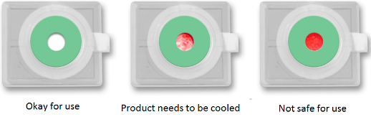
- Prior to administering any blood products, the provider shall confirm the product type and expiration date with a second provider.
- Spike a unit of whole blood (or PRBC) with the empty Y-port of the tubing. Close off the roller clamp for the saline, and open the roller clamp on the blood. Note: only one of the ports should be running at one time. | 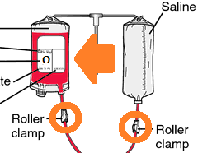
- To spike a bag of whole blood (or PRBCs), choose one of the ports on the bag, peel back the covering to expose the port, then utilize the Y-port to spike the bag.
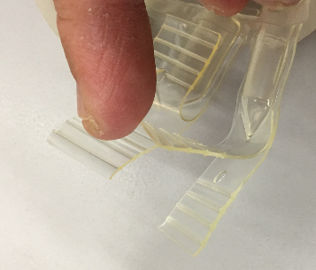
- To spike a bag of plasma or platelets, twist off the highlighted cap below, then utilize the Y-port to spike the bag.
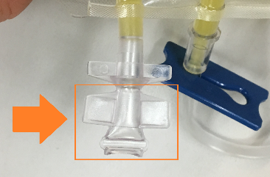
- Infuse the blood products at an appropriate rate (pressure infuse if necessary), verifying the in-line filter is flowing correctly with no clotting.
  - Pediatric dosing is 10 – 20 ml/kg to start, titrated to effect.
  - If administering products to a smaller pediatric patient, utilize a syringe for controlled and accurate dosing.
  - Goal is administration of products in 1:1:1 ratio (or whole blood) when practical.

- Upon infusing products, Providers shall record the Unit Number or W Number on the Field Transfusion Record (pictured below). If the product doesn’t have a sticker, the provider shall write it in the appropriate spot on the form.

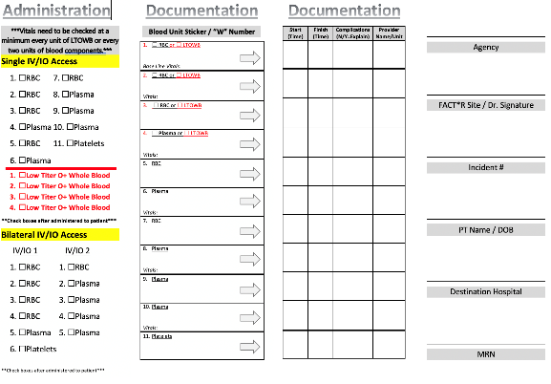

- Each blood product will be accompanied by its own triplicate form (pictured below). The provider is not responsible to complete this form. Only the OMD or authorizing physician will sign this form.

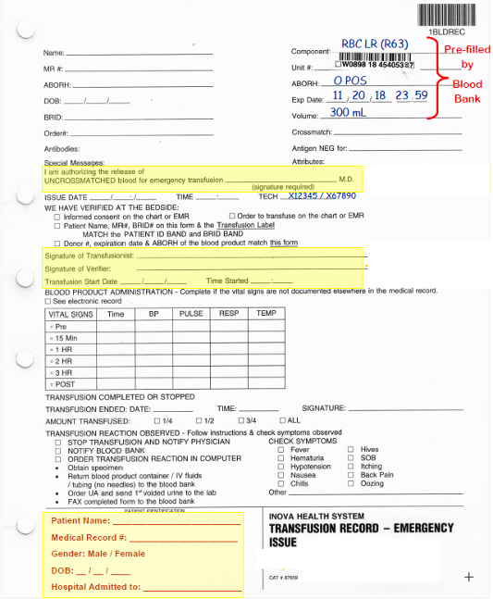
- While the first unit of product is infusing, prepare the next bag of blood product as outlined in steps 28-35 for use on the other side of the Y port. Upon administration of the first full bag of blood product (or appropriate pediatric dose), close its roller clamp, and open the roller clamp for the next appropriate product.

- Remove the empty bag of blood product and replace it with next bag of product. If products still remain in the bag of, prevent them from leaking out.
- Proper sequence of blood product administration (if not using whole blood) is:
  - Start with 2 units PRBCs (for adults) then infuse equal amounts of PRBCs and Plasma.
  - Platelets would be administered last.
  - End point for transfusion is evidence of adequate perfusion.
- During administration be sure to check the filter for adequate flow, and the lower part of the tubing for smooth flow and absence of clot formations.
- If clot formation is noted or flow rate becomes slow, discontinue administration, and disconnect the set-up from the patient. A new set of blood tubing and Warrior disposable unit should be used if additional blood products are needed.
- Periodically verify the temperature input/output on the QinFlow Warrior.
- If an alarm sounds on the QinFlow Warrior, immediately observe the LCD screen and take appropriate action as necessary. If the alarm is due to a high temperature and Warrior does not automatically correct in a few seconds, immediately discontinue administration, and troubleshoot per manufacturer guidelines.
- If a second IV site is available and supplies allow, begin at step 7 above to begin administering warm IV fluids and additional products through second site as indicated.
- For component transfusion, upon complete administration of PRBCs and plasma, begin administration of platelets. Do not warm the platelets. Prior to platelet administration, remove the blood tubing from the inlet luer of the QinFlow Warrior and connect directly to the patient’s IV.
  - Adult: administer the full unit
  - Pediatric: administer 10 ml/kg
- All used blood product supplies (bags, tubing, Disposable Unit, etc.) shall be left with the patient for later analysis.
- Unused FACT*R products may potentially be used/returned to the blood bank. Coordinate with blood banks (receiving facility and origin facility) to discuss procedure for return of unused blood as needed. The receiving facility will be able to determine viability of the remaining products and assist with additional cooling if necessary for return.
- Complete the Field Transfusion Record that came with the blood in its entirety. The ability to link each unit of blood products to the exact patient that received that unit of blood product is extremely important. The physician signature will be the physician who authorized the blood.
- The completed form must be submitted as soon as practical but no greater than 72 hours after administration. This includes the authorizing physician signature.

_________________________________________________
John I. Morgan, M.D., LC-CFRS Operational Medical Director

